AN ACT RELATIVE TO SUPPORTED DECISION-MAKING AGREEMENTS
FOR CERTAIN ADULTS WITH DISABILITIES
Sen. Joan Lovely (SD.1746), Rep. Paul Tucker (HD.2134)
Supported decision-making (SDM) allows adults, including those with disabilities and elders, to maintain their rights, dignity, and independence by choosing one or more trusted supporters to provide assistance making decisions about their lives.
SDM enables individuals with disabilities or cognitive limitations who may require assistance to make their own decisions with support, instead of having someone else, usually a guardian, make decisions for them. The arrangement is memorialized in a simple written agreement setting out the roles for the supporters (those who provide support) and the individual with the need for assistance (those who make the decisions). SDM has been gaining substantial momentum internationally, across the United States and, since 2014, through innovative pilot projects in Massachusetts.
THE NEED: Too many people are unnecessarily placed under restrictive guardianships when they would be able to make their own decisions if they received individualized assistance from people they trust, allowing them to retain their legal rights and dignity.
THE SOLUTION: Supported decision-making. Ten other jurisdictions already have laws that provide clear legal authority and effective processes for SDM arrangements—Texas, Wisconsin, Alaska, Delaware, District of Columbia, Indiana, North Dakota, Nevada, Louisiana, and Rhode Island.
Respected national organizations and federal agencies have recommended and endorse using supported decision-making as an alternative to guardianship, including: American Bar Association, National Guardianship Association, the Arc of the United States, the U.S. Department of Education, U.S. Department of Health and Human Services, and the National Council on Disability.
This bill would establish the legal framework for SDM in Massachusetts. The bill would:
- define SDM and establish roles for those involved
- allow people with disabilities and elders to enter into a SDM agreement with people they trust, or “supporters”
- establish required elements of an SDM agreement form
- create protections against abuse of the model
- require that courts first consider SDM before establishing a guardianship
- establish training for people using the model (supporters and decision-makers)
- ensure all youth turning 18 are made aware of the SDM option at Individualized Educational Plan (IEP) meetings
Passing this bill would save time and money in probate courts by reducing the number of guardianship petitions for people who do not need them.
SDM does not replace guardianship. It is an additional and less restrictive option.

Supported Decision-Making: Stories of Success in Massachusetts

Cory lives in the Berkshires, where he works with the Advantage Employment Network and in other jobs. Cory is on the Autism Spectrum and at times experiences symptoms from Obsessive Compulsive Disorder and anxiety.

When Cory was approaching 18, guardianship was the only option presented by his school. Cory did need help making decisions about his finances, health, and other issues, but his parents were unable to find any alternative to guardianship.

In January 2015, Cory and his family learned about the Supported Decision-Making Pilot Project run by the Center for Public Representation and Nonotuck Resource Associates and decided to try out this new model of support. Cory identified his supporters and which areas of his life he would need help with decisions. He filled out a SDM agreement reflecting his choices.

On November 17, 2015, a Probate Court judge granted Cory’s petition to terminate his guardianship in favor of his SDM agreement. This is the first time that a MA resident has relinquished a guardianship in favor of a SDM Agreement.

In Cory’s own words:
- “[Ending the guardianship was] very special because I felt my own freedom for the first time.”
- “Supported decision-making is really important to me. I love my family and they will always be there to support me.”
- “This is my journey now.”
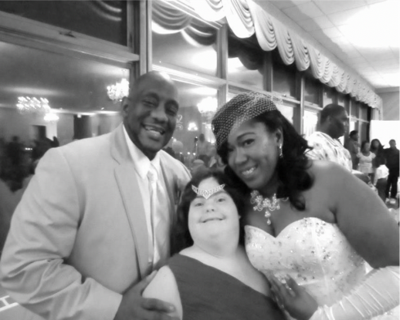
Amanda is a young woman who is an avid traveler from the Berkshires, and who loves the New England Patriots and WWE. Amanda has Down syndrome and at times needs support and clarity in understanding issues before making decisions. Amanda decided to try SDM. Her mother and a long-time friend are among the supporters she chose. One of her supporters, Sandy, believes that SDM is a great option for Amanda who “directs the course of her life and knows when she needs clarity in understanding decisions. [Supported decision-making] has given Amanda the continued opportunity to stay as independent as possible; this is what Amanda and her team both want.”

Amanda says: “[Supported decision-making] is great for me because I get to make my own decisions with help from my team.”

